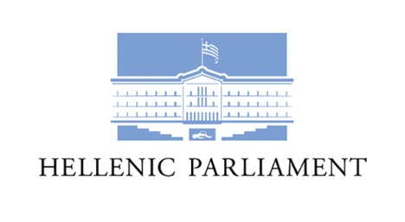

**2nd Meeting of**

**Medical Services**

**of EU 27+ Parliaments**

**Athens, September 28th – 29th 2023**

**Senate Hall**

**Thursday, September 28th**

12.45 - 13.30 Arrival at the premises of the Hellenic Parliament

Registration of participants (Senate Hall)

13.40 Opening session by Dr. Natalia Tzima, internist, Head of the Hellenic Parliament’s Health service unit

Message conveyed by the President of the European Parliament, Mrs. Roberta Metsola

Welcome remarks by Mr. Vassilios Oikonomou, President of the Standing Committee on Social Affairs

14.00 Introduction – “EU 27+ National Parliaments and European Parliament Medical Services network so far – Presenting the Hellenic Parliament’s Health service unit”

Dr. Natalia Tzima

Ιnternist, Head of the Hellenic Parliament’s Health service unit

14.20 Services, human resources and structures of the parliamentary health units – Q& A – Discussion

Coordinators: Mr. Giorgos Korlos*,*

Cardiologist, Deputy-Head of the Hellenic Parliament’s Health service unit

Dr.Theodoros Spiropoulos

Ιnternist of the Hellenic Parliament’s Health service unit

15.00 - 15.30 Coffee Break

15.30 Thematic session: “Promoting health, resilience and wellbeing in Parliaments”

Dr. Natalia Tzima

Internist, Head of the Hellenic Parliament’s Health service unit

16.00 “Α SWOT analysis of the network”

Workshops - Senate Hall and Room 150

16.30 – 16.50 Coffee Break

17.00 Discussion based on SWOT analysis

17.30 – 18.15 Guided tour of the Hellenic Parliament and the exhibition “Beholding Liberty! At the Hellenic Parliament two centuries later”

20.00 Dinner hosted by the Hellenic Parliament at “Athens View Balcony” restaurant at Elia Ermou Hotel (15-17, Ermou Str.)

**Friday, September 29th**

09.00 Optional visit of the dental clinic, physiotherapy and nutrition office

(1, Mitropoleos Str.)

10.10 Thematic session: “Integrative medicine in the Hellenic Parliament: Behavioural Cardiology”

Mr. Giorgos Korlos

Cardiologist, Deputy-Head of the Hellenic Parliament’s Health service unit

10.30 Thematic session: “Promoting a healthy lifestyle through nutrition changes”

Dr. Fotini Arvaniti

Dietician-nutritionist of the Hellenic Parliament’s Health service unit

11.00 Coffee Break

11.30 Family Photo

11.40 Thematic session: Mass Media as communication channels on health issues”

Mrs Alexia Koulouri

Reporter, Chief Editor of the Hellenic Parliament TV Station

12.10 “Why – what - how analysis. Discussing the network‘s vision and values”

Workshops - Senate Hall and Room 150

13.00 “Establishing a common action: Organising a health day awareness”

Workshops - Senate Hall and Room 150

13.40 Resumption of workshops - Conclusions

14.00 – 15.30 Lunch at the Hellenic Parliament’s restaurant